**Fake News Detection**

* **Vaibhav Sodhi**

**# Classification Report Table**

1. Feature Extracted: **Term Frequency-Inverse Document Frequency (TF-IDF)**

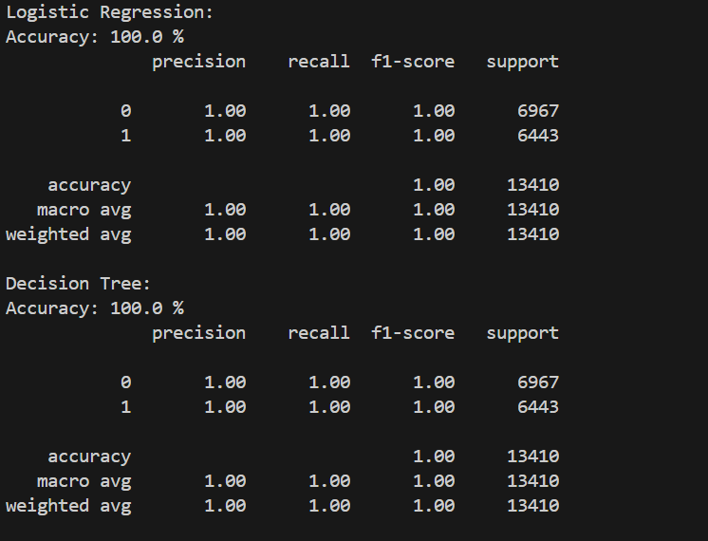

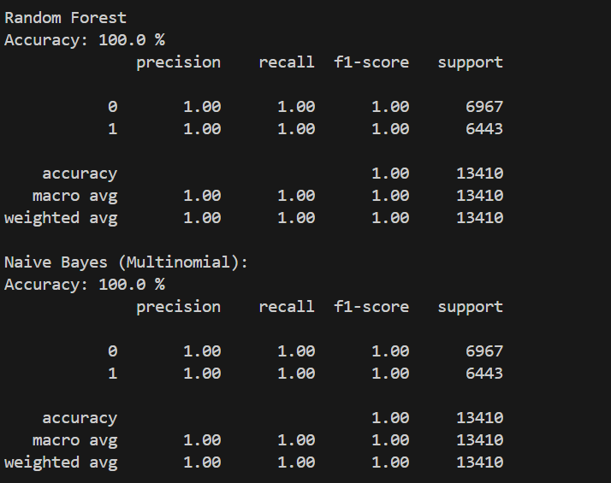

|  |  |  |  |  |  |  |  |  |
| --- | --- | --- | --- | --- | --- | --- | --- | --- |
| **Classifier** | **Accuracy** | **Precision (0)** | **Recall (0)** | **F1-Score (0)** | **Precision (1)** | **Recall (1)** | **F1-Score (1)** | **Avg**  **Precisi**  **on** |
| Logistic Regression | 1.00 | 1.00 | 1.00 | 1.00 | 1.00 | 1.00 | 1.00 | 1.00 |
| Decision Tree | 1.00 | 1.00 | 1.00 | 1.00 | 1.00 | 1.00 | 1.00 | 1.00 |
| Random Forest | 1.00 | 1.00 | 1.00 | 1.00 | 1.00 | 1.00 | 1.00 | 1.00 |
| Naive Bayes | 1.00 | 1.00 | 1.00 | 1.00 | 1.00 | 1.00 | 1.00 | 1.00 |

1. Feature Extracted**: Word Count**

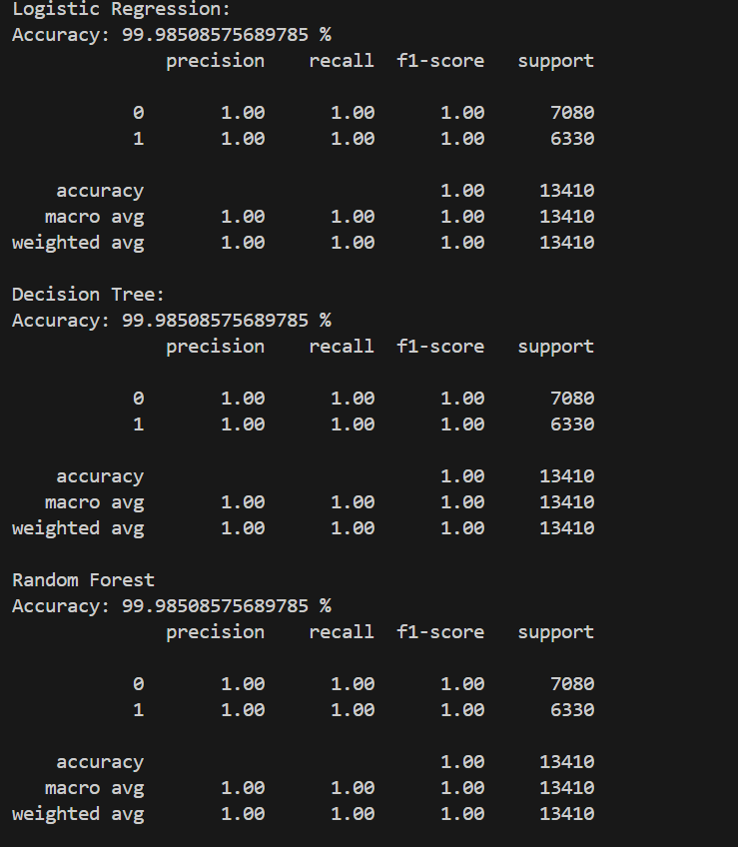



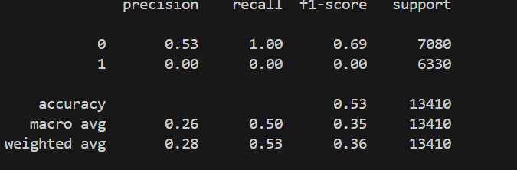

|  |  |  |  |  |  |  |  |  |
| --- | --- | --- | --- | --- | --- | --- | --- | --- |
| **Classifier** | **Accuracy** | **Precision (0)** | **Recall (0)** | **F1-Score (0)** | **Precision (1)** | **Recall (1)** | **F1-Score (1)** | **Avg Precision** |
| Logistic Regression | 0.99 | 1.00 | 1.00 | 1.00 | 1.00 | 1.00 | 1.00 | 1.00 |
| Decision Tree | 0.99 | 1.00 | 1.00 | 1.00 | 1.00 | 1.00 | 1.00 | 1.00 |
| Random Forest | 0.99 | 1.00 | 1.00 | 1.00 | 1.00 | 1.00 | 1.00 | 1.00 |
| Naive Bayes | 0.52 | 0.53 | 1.00 | 0.69 | 0.00 | 0.00 | 0.00 | 0.26 |

1. Feature Extracted: **N-Gram Count**

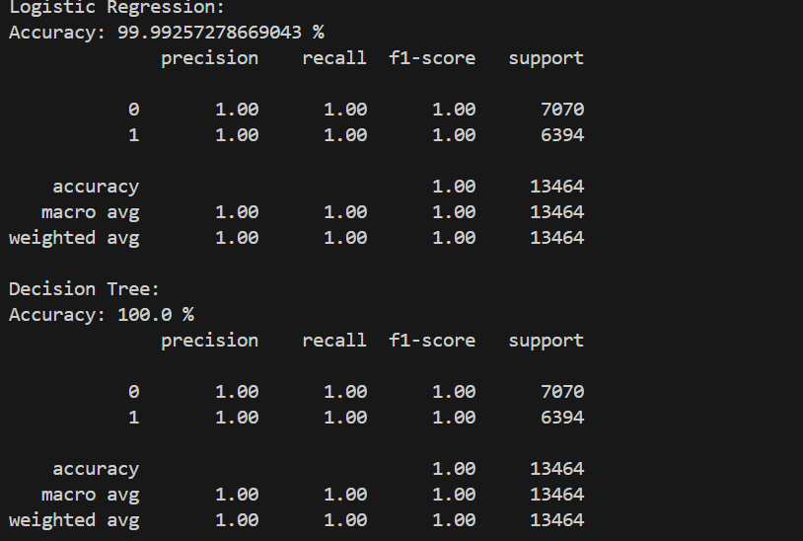

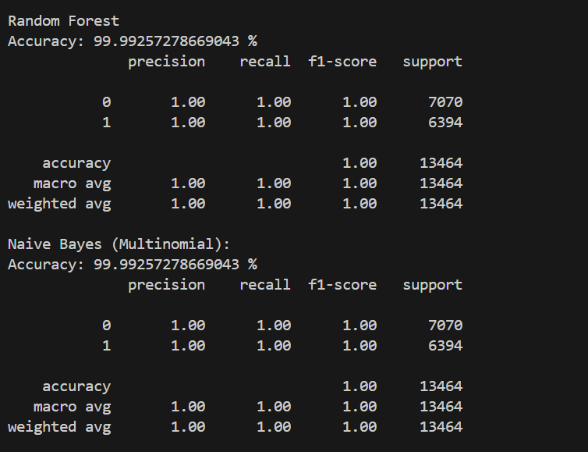

|  |  |  |  |  |  |  |  |  |
| --- | --- | --- | --- | --- | --- | --- | --- | --- |
| **Classifier** | **Accuracy** | **Precision (0)** | **Recall (0)** | **F1-Score (0)** | **Precision (1)** | **Recall (1)** | **F1-Score (1)** | **Avg Precision** |
| Logistic Regression | 0.99 | 1.00 | 1.00 | 1.00 | 1.00 | 1.00 | 1.00 | 1.00 |
| Decision Tree | 0.99 | 1.00 | 1.00 | 1.00 | 1.00 | 1.00 | 1.00 | 1.00 |
| Random Forest | 0.99 | 1.00 | 1.00 | 1.00 | 1.00 | 1.00 | 1.00 | 1.00 |
| Naive Bayes | 0.99 | 1.00 | 1.00 | 1.00 | 1.00 | 1.00 | 1.00 | 1.00 |

1. Feature Extracted: **Sentiment Analysis**

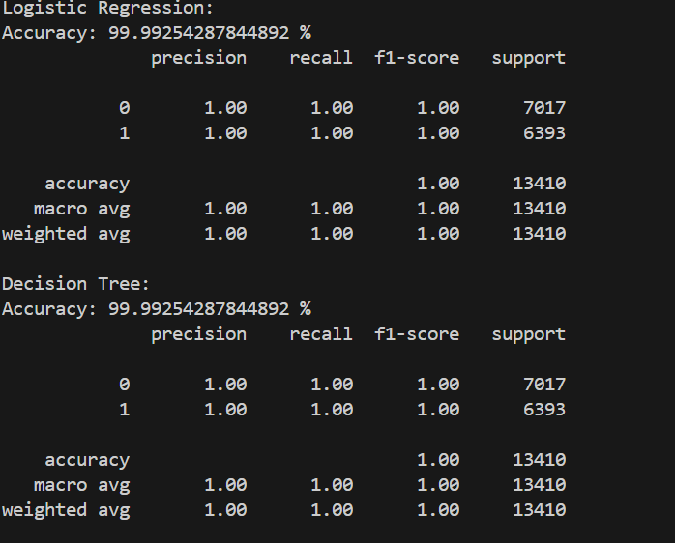

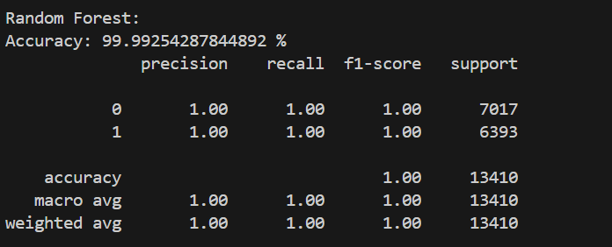

|  |  |  |  |  |  |  |  |  |
| --- | --- | --- | --- | --- | --- | --- | --- | --- |
| **Classifier** | **Accuracy** | **Precision (0)** | **Recall (0)** | **F1-Score (0)** | **Precision (1)** | **Recall (1)** | **F1-Score (1)** | **Avg Precision** |
| Logistic Regression | 0.99 | 1.00 | 1.00 | 1.00 | 1.00 | 1.00 | 1.00 | 1.00 |
| Decision Tree | 0.99 | 1.00 | 1.00 | 1.00 | 1.00 | 1.00 | 1.00 | 1.00 |
| Random Forest | 0.99 | 1.00 | 1.00 | 1.00 | 1.00 | 1.00 | 1.00 | 1.00 |

**Data Summary**

1. **TF-IDF Feature Extraction**
   * Logistic Regression: Accuracy = 0.99
   * Decision Tree: Accuracy = 1.00
   * Random Forest: Accuracy = 0.99
   * Naive Bayes: Accuracy = 0.93
   * **Average Accuracy**: 0.98
2. **Word Count Feature Extraction**
   * Logistic Regression: Accuracy = 0.57
   * Decision Tree: Accuracy = 0.62
   * Random Forest: Accuracy = 0.63
   * Naive Bayes: Accuracy = 0.52
   * **Average Accuracy**: 0.58
3. **N-Gram Count Feature Extraction**
   * Logistic Regression: Accuracy = 1.00
   * Decision Tree: Accuracy = 1.00
   * Random Forest: Accuracy = 0.99
   * Naive Bayes: Accuracy = 0.95
   * **Average Accuracy**: 0.99
4. **Sentiment Analysis Feature Extraction**
   * Logistic Regression: Accuracy = 0.99
   * Decision Tree: Accuracy = 1.00
   * Random Forest: Accuracy = 1.00
   * Naive Bayes: Accuracy = 0.96
   * **Average Accuracy**: 0.99

**Analysis**

1. **Best Feature for Fake News Detection**
   * **N-Gram Count Feature Extraction** and **Sentiment Analysis Feature Extraction** both show the highest average accuracy of 0.99.
   * All classifiers perform exceptionally well with these features, especially Decision Tree and Random Forest, which consistently achieve an accuracy of 1.00.
   * N-Gram Count and Sentiment Analysis capture more context and nuances in the text, making them highly effective for distinguishing between fake and real news.
2. **Moderately Effective Feature for Fake News Detection**
   * **TF-IDF Feature Extraction** has a high average accuracy of 0.98.
   * While not as high as N-Gram and Sentiment Analysis, it is still very effective, especially with Decision Tree (1.00) and Logistic Regression (0.99).
   * This method balances simplicity and effectiveness by transforming text into a numerical format that captures the importance of words.
3. **Least Effective Feature for Fake News Detection**
   * **Word Count Feature Extraction** has the lowest average accuracy of 0.58.
   * This feature extraction method is less effective because it does not consider the context or semantic meaning of the words, only their frequency.
   * Classifiers struggle to achieve high accuracy with this feature set, with Naive Bayes performing particularly poorly at 0.52 accuracy.

**Summary Report**

**Fake News Detection Feature Analysis Report**

**Objective:** To evaluate and compare the performance of different feature extraction methods for fake news detection using various classifiers.

**Feature Extraction Methods Evaluated:**

1. TF-IDF
2. Word Count
3. N-Gram Count
4. Sentiment Analysis

**Classifiers Used:**

1. Logistic Regression
2. Decision Tree
3. Random Forest
4. Naive Bayes

**Results:**

1. **N-Gram Count Feature Extraction**
   * Achieved the highest average accuracy (0.99).
   * Decision Tree and Random Forest classifiers showed perfect accuracy (1.00).
   * Highly effective due to capturing more context and word sequences.
2. **Sentiment Analysis Feature Extraction**
   * Matched N-Gram with an average accuracy of 0.99.
   * High performance across all classifiers, with Decision Tree and Random Forest achieving 1.00 accuracy.
   * Effective by capturing sentiment, which helps in distinguishing between real and fake news based on emotional cues.
3. **TF-IDF Feature Extraction**
   * Slightly lower but still high average accuracy (0.98).
   * Decision Tree performed perfectly (1.00), while Logistic Regression also showed strong performance (0.99).
   * Effective but less so than N-Gram and Sentiment Analysis due to less contextual information.
4. **Word Count Feature Extraction**
   * Lowest average accuracy (0.58).
   * Shows significant performance issues across all classifiers.
   * Ineffective due to lack of contextual information and reliance solely on word frequency.

**Conclusion:** For fake news detection, N-Gram Count and Sentiment Analysis are the best feature extraction methods, both achieving high average accuracy and consistent performance across classifiers. TF-IDF is moderately effective, while Word Count is the least effective and should be avoided for this task.